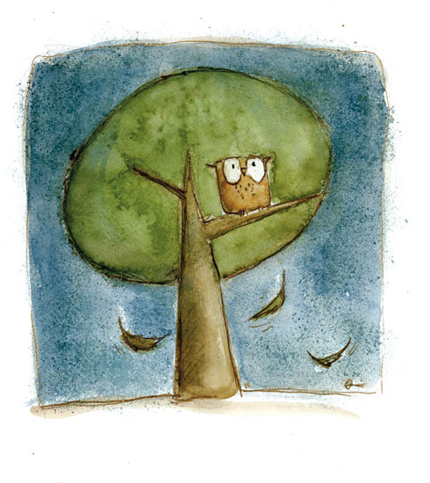

The best poems

in England!

Student`s essays!

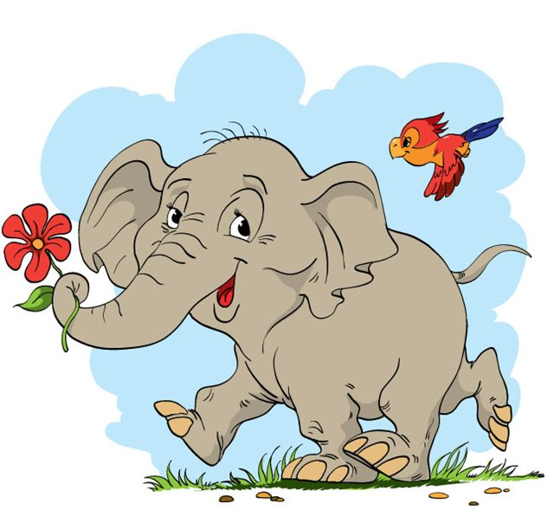
Belehov Pavel

A Mouse and a House

I have a house.
House has a mouse.
My house is not bad
And it is the mouse`s flat.
I do not like the mouse,
But mouse likes my house.
She lives under the floor.
I like my very good door.
I closed my door
And I see the mouse no!
I open the door.
Mouse goes under the floor.

Stepanov Vitalik

Clothes for animals

A Cat sleeps in pajamas
And Dog goes trousers.
A Lamb runs beside shorts.
Duck flies over boots.
Goat dresses mittens.
Kid takes jeans.
Swan soils shirt
Elk eats T-shirt.

Pleshkov Yura

A dog and a Frog

A small Dog likes a Frog
And the Frog likes the Dog.
Dog plays with Frog.
And the Frog is a friend of the dog.
They are friends, friends, friends.
And they are my good friends!

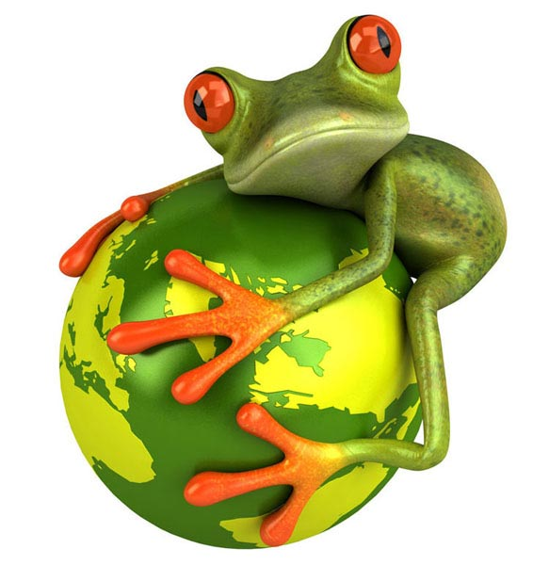

Kubasova Ann

Kittens

One kitten,
Two kittens,
Three kittens,
Their mother counys.
Four kittens,
Five kittens,
Six kittens,
They can not count!

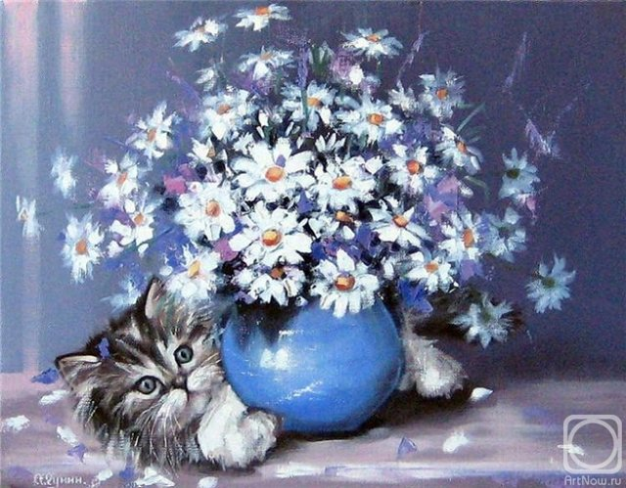

Lehin Yura

My cat

Cat is small.
He lives in the hall.
His name is Tom.
He likes his home.
Cat can run and play,
But he can`t say.
I like my cat,
My cat is fat.

Smirnova Pollya

Disorder

A Wolf likes a Rabbits.
The Rabbits like cabbages.
The Cabbages like water.
I like rabbits,
I like cabbages,
I like water, too.
But I do not like wolf.

Dubov Maxim
The animals
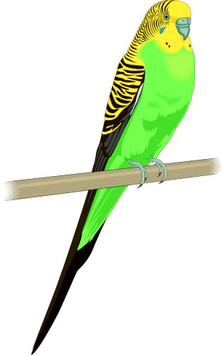
The animals are good.
I have got a good Kind mood.
Giraffe is tall.
Mouse is small.
Wolf is wild.
Dog is kind.
Tiger is angry.
But he is always hungry.
I don’t like bear,
Bat I like hare.
Clever red fox
Doesn’t like dogs.
I like slow donkeys,
I don’t like monkeys,
I like to go to the zoo,
There are a lot of Kangaroo.

Travin Iliya

Zoo

We go to zoo.
We saw a cow.
We go in house.
We saw a mouse.
Mouse runs to the zoo.
And saw the cow.
Mouse saw a meet
And she swallowed the sheet.

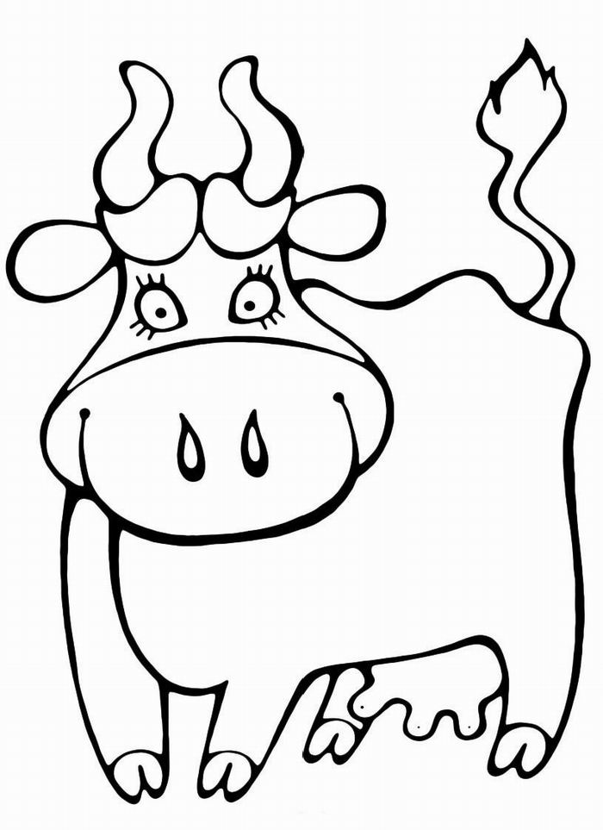

My Cow
“
“Where was my dear cow?”
I say.
“I am on a visit to crow.”
She says.
“What did you hear, dear cow?”
I say.
“Many interesting stories.”
She says.

Elkina Kseniya

My family

I have a brother,
I have a mother,
I have a father,
I have a aunts.
I have a sister,
I have a dog.
I have a uncles.
I have a frog.
I have a cat.
We live in the flat.

Neganov Yura

Dubov Maxim

The school

Every day I go to school.
I think, it is cool!
I like physical training
And I like playing.
I am waiting for my holiday!
Because I will have a nice day!
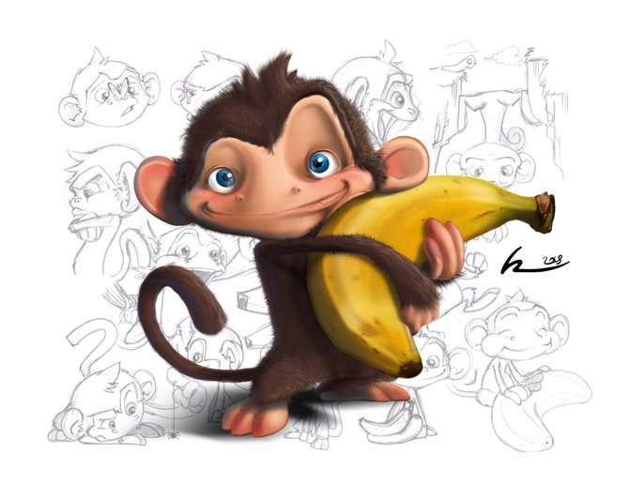

Belehov Pavel
The zoo

We go every day to zoo.
There every day some one grass mow
For in older to feed animals.
There live many camels
And hares.
But there live shakes.
And live very many monkeys.
Neigh boars monkeys and donkeys
Near live a buffalo
Their neighbours are hippopotamus
We see many animals in zoo.
But yet this is the magis world of animals.

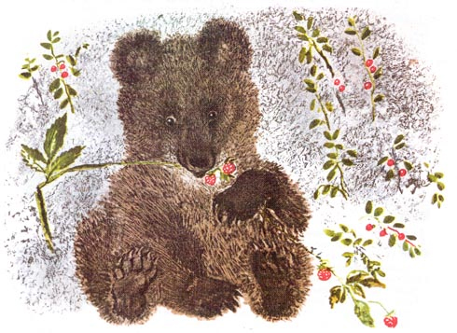
Lyhin Urer

My family

I have a brother,
I have a cat.
I have a mother.
I have a bed.
I have seven aunts.
I have two the uncles.
I compose a poem.
I`ll receive five.

Skryabina Rita

A Tiger

A tiger lives in the zoo.
The Tiger is big.
Tiger is brown,
Tiger is brave.
Tiger likes a ham.
He has mum.
His mum likes him!

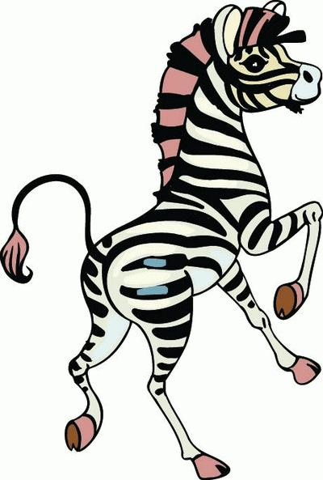

A Zoo

Zoo park has old.
Monkey, zebra, giraffe, crow
They play much every day.
They sleep much every night.
Monkey there go to food.
Monkey, zebra, giraffe, crow.
Eat leaf, grass, banana.
Animals go to drink.
Monkey, zebra, giraffe.

Salnikov Nikita

